Machine Problem 4(Python) Screenshots:

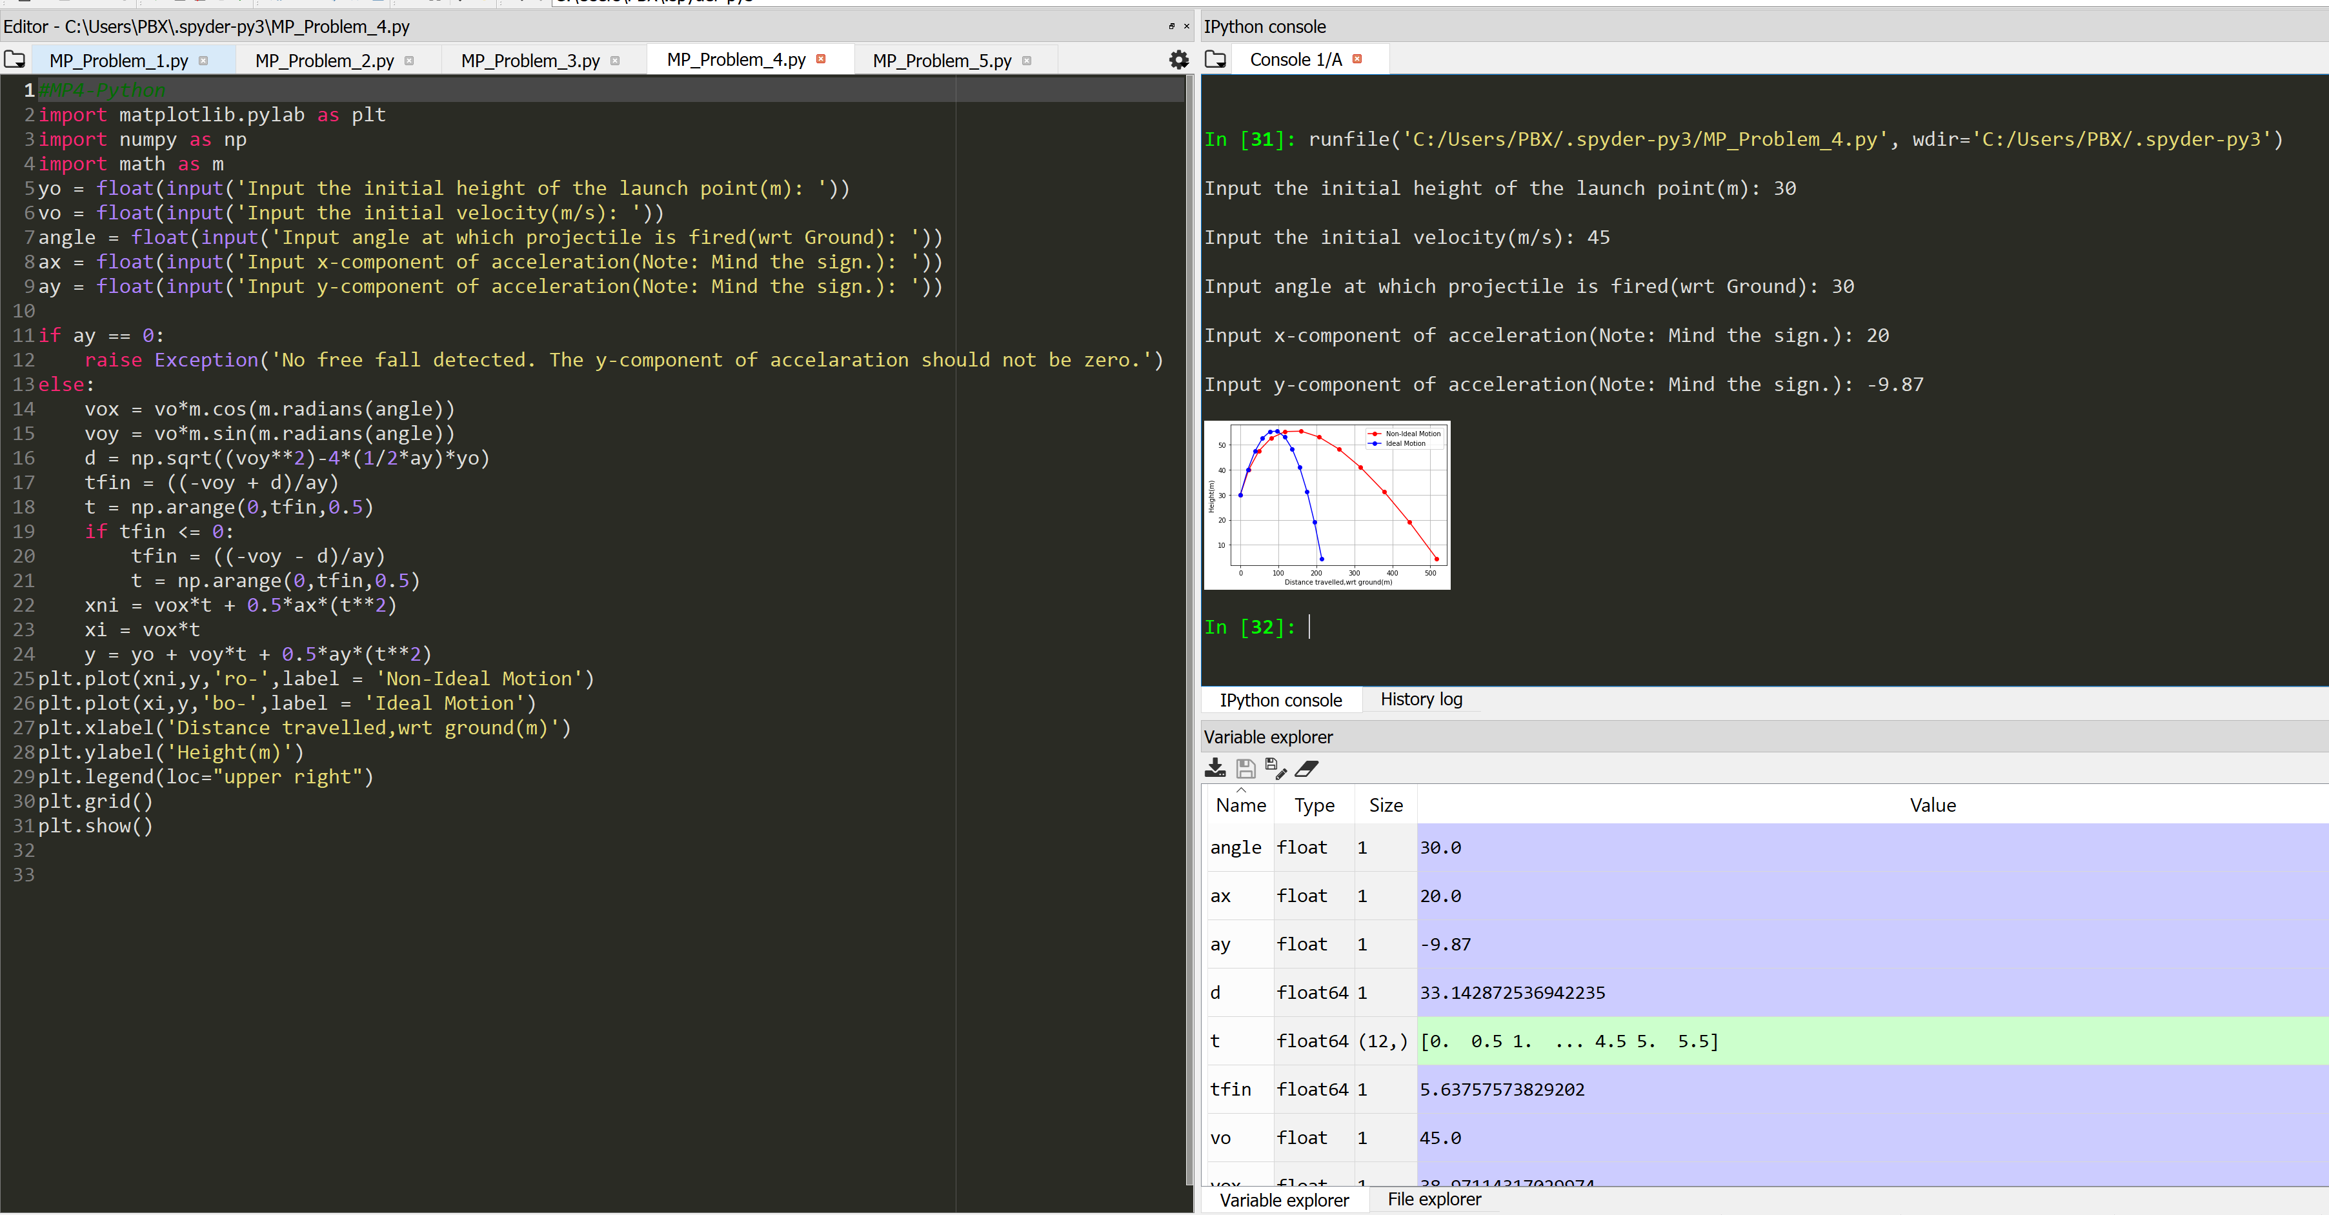

Picture Code testing with the following inputs: yo =30m, vo = 45m/s, angle = 30 , ax = 20m/s2, ay = -9.87m/s2

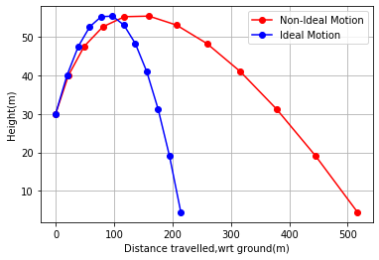

Figure Resulting Trajectory of the Projectile

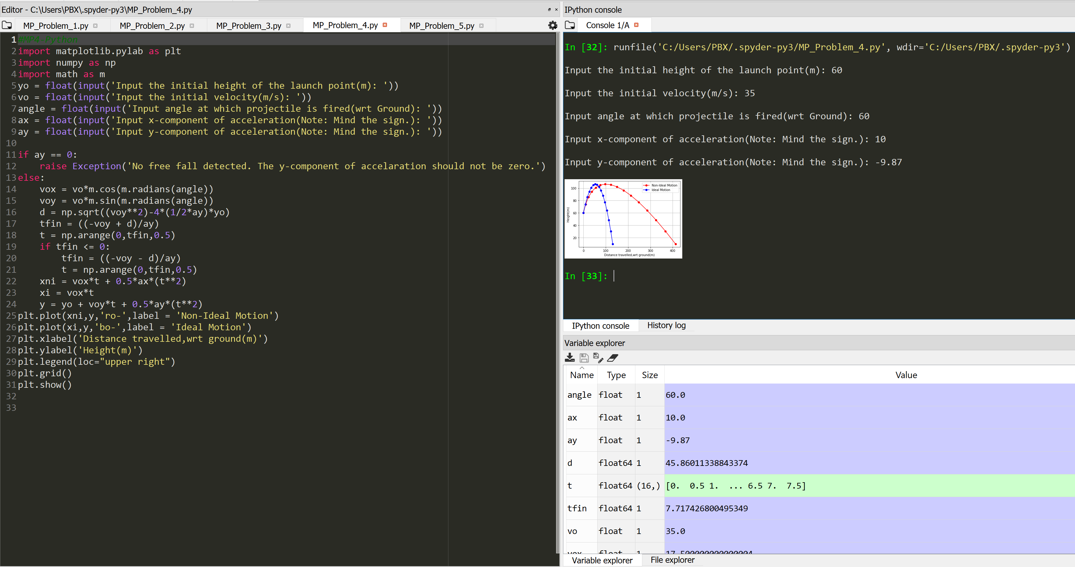

Picture Code testing with the following inputs: yo =60m, vo = 35m/s, angle = 60 , ax = 10m/s2, ay = -9.87m/s2

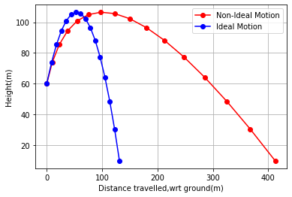

Figure Resulting Trajectory of the Projectile

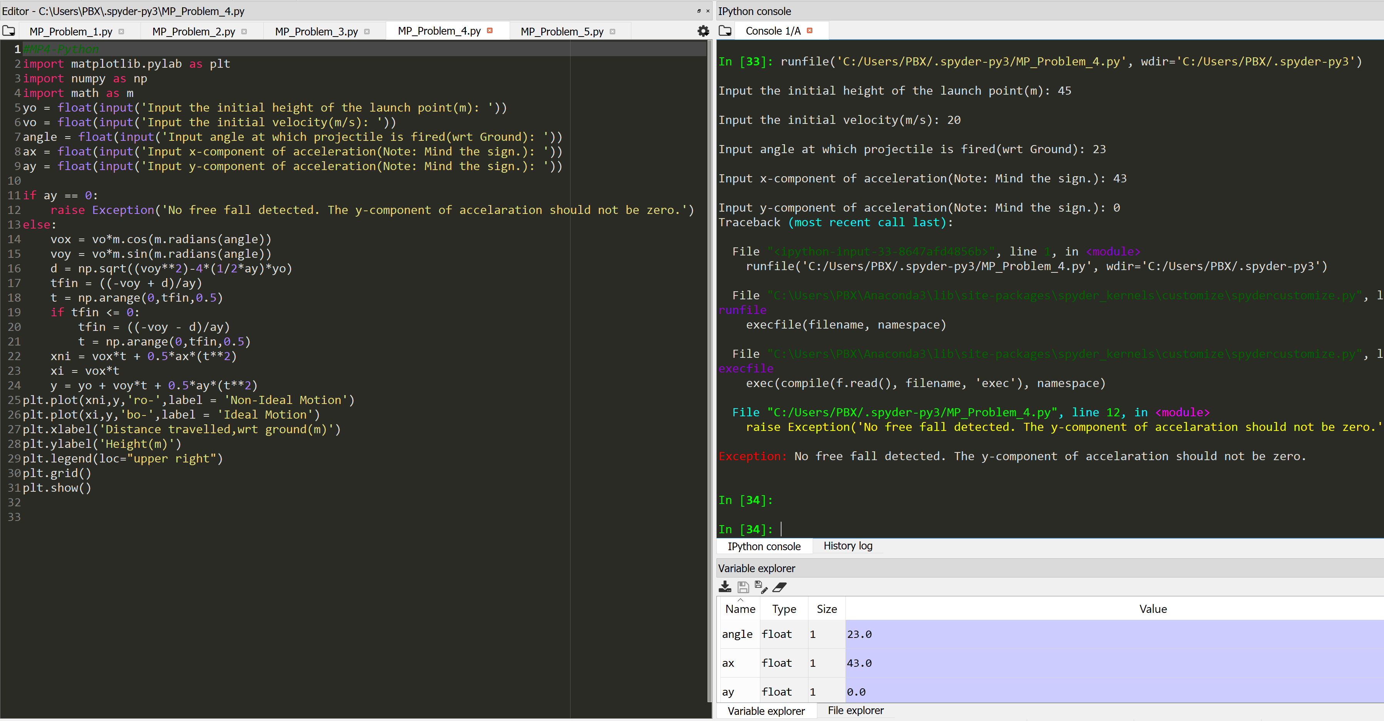

Figure Error Code Testing with ay = 0.